Membership Registration Form
All business owners and property owners within the Hastings North Business Improvement Area are invited to attend the Annual General Meeting of the Hastings North BIA. A business or property owner has the right to appoint a representative who is affiliated with their business to attend and vote at the AGM on their behalf. The boundaries of the area are Renfrew Street, East Hastings Street, Clark Drive, East Pender Street, Powell Street, Semlin Drive, Victoria Drive, and Turner Street. All business and property owners within these boundaries are members of the BIA and are eligible to vote at the Annual General Meeting by completing a Membership Application or Representative Form.
Membership Application Appointment of Representative

In effect for one year, provided member stays in good standing.

Company Name:
The Hastings North Business Improvement Association hereby appoints the following person

Or failing him / her,

Business Address:

Property Owner:
Business Owner:
Name (please print): Telephone Number: Fax Number: E-mail Address:
Complete and return this registration form to the Hastings North BIA Office by email or mail no later than September 10, 2019 before 4:30pm.
As a representative for the undersigned, being a member of good standing of the Hastings North Business Improvement Association.
The aforementioned individual has the authority from the undersigned to vote on the behalf of the undersigned at the 2019 Annual General Meeting of
the Hastings North Business Improvement Association to be held on Tuesday, September 17, 2019, 12:00pm at the Hastings North BIA Office - Upstairs (2618 East Hastings St) and at any adjournments thereof.
Date: Business Name: Tel/Fax: Contact Name: Signature:

Please Circle the Appropriate Reply
YES, I will be attending the Annual General Meeting on September 17, 2019
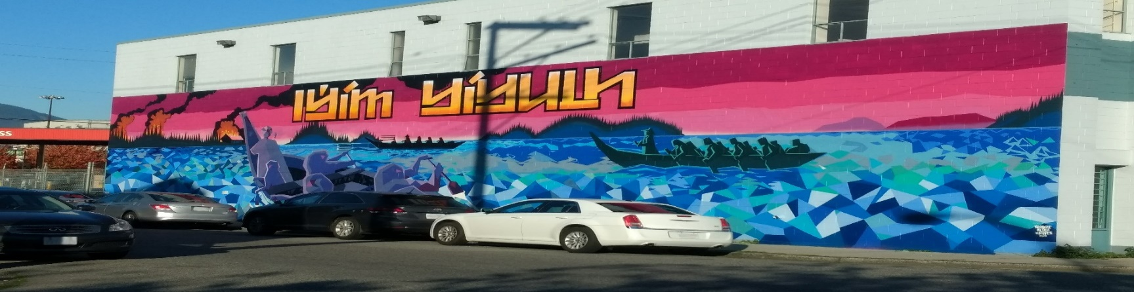
NO, I will not be attending the Annual General Meeting on September 17, 2019

